                                 **User Manual for Google Keep**

**About Google Keep**

Google Keep is a free note-taking app that allows you to create, edit, organise, and share notes. Keep is a great way to keep track of your thoughts, ideas, and tasks. You can use it to create to-do lists, priorities, meeting notes, or anything else you need to remember. It is available on Android, iOS, and the web. To use keep, sign in with your Google account on iOS, for android any existing Google account can be used.

Link to the app: <https://rb.gy/w5lr8>

**Features**

Keep has a number of features that make it a powerful note-taking app.

1. Keep notes in a wide form of format, such as test, image, list, audio, and sketch.
2. Labelling: You can label your notes to organise them by topic or project.
3. Colour coding: You can colour code your notes to make them easier to find.
4. Reminders: You can set reminders for your notes so you don't forget about them.
5. Sharing: You can share your notes with others so they can collaborate with you.

**Getting Started**

To get started with Keep, you can download the app from the Play Store or the App Store. Once you have installed the app, you can create a new note by tapping the "+" button.

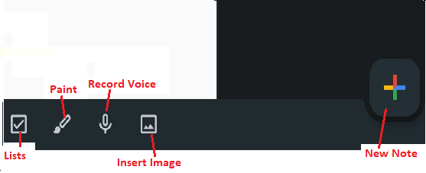 Image of features location on Google keeps to start on creating a note.

* **Creating Notes**

To create a text note, simply type your note into the text field. To create a voice note, tap the microphone button and start speaking. To create a to do list, click on list, and start listing. To add an image to your note, tap the "Image" button and then select an image from your device. To draw or sketch a note, click the pencil icon and begin your journey.

You can also use the Keep web app to create and edit notes. To access the web app, go to <https://keep.google.com/>.

* **Organising Notes**

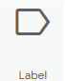You can organise your notes by labels and colours. To add a label to a note, tap the label button and select a label. To colour a note, tap the colour button and select a colour.

* **Sharing Notes**

To share a note, tap the "Share" button and then select the people you want to share the note with.

You can also share a note by sending a link to the note. To get a link to a note, tap the "Share" button and then tap "Copy link."

* **Setting Reminders**

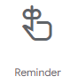To set a reminder for a note, tap the reminder button and select a date and time. You can also set a repeating reminder.

* **Searching for Notes**

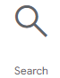To search for notes, tap the search bar and type your search terms. You can search a note by its text, label, or colour.

* **Archive Notes**

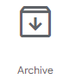If you notice any unwanted note on screen, you may use the archive feature to refer to the note later, or for any future requirement.

For more information or any help, please visit [www.support.google.com/keep/](http://www.support.google.com/keep/).